**Emotion-Based Product Defect Identification: Harnessing Consumer Reviews for Predictive Insights**

**Michael X Pacheco**

**Table of Contents**

**Introduction** 3

**Problem Statement** 3

**Justification of the Problem's Importance** 3

**Customer Retention** 3

**Brand Reputation** 3

**Cost Efficiency** 3

**Informed Decision Making** 3

**Pitching to Stakeholders** 3

**Data Source Explanation** 4

**Data Reading Using API** 4

**Data Reading from Crawled Extracted File** 4

**Data Preprocessing** 4

**Natural Language Processing** 4

**Exploratory Data Analysis** 4

**Data Distribution** 4

**Review Length Analysis** 4

**Word Counts** 4

**Data Preparation** 5

**Text Transformation** 5

**Feature Engineering** 5

**Model Building and Evaluation** 5

**Conclusion** 5

**What does the analysis/model building tell you?** 6

**Is this model ready to be deployed?** 6

**Recommendations** 6

**Challenges** 6

**Opportunities** 6

# **Introduction**

In the contemporary competitive market, the assurance of product quality holds the utmost significance for firms to flourish. It is commonly asserted that a satisfied consumer serves as a highly effective marketing tool for a corporation. Conversely, it is also important to note that a solitary disgruntled client has the capacity to dissuade multiple prospective customers through the dissemination of bad feedback. The proliferation of online retail platforms has led to an abundance of consumer input in the form of product reviews. The sentiments conveyed by consumers within these reviews can provide valuable insights. By utilizing the available emotional data, enterprises possess a distinct potential to detect and address product flaws promptly.

## **Problem Statement**

The task of interpreting the true sentiment expressed in customer evaluations, particularly in relation to detecting product defects, poses a significant challenge for businesses despite the abundance of available reviews. Conventional review analytics typically focus on determining the polarity of a review, i.e., whether it is good or negative. However, the intricate nuances of customer emotions, such as irritation, disappointment, or wrath, are sometimes disregarded in this process. There exists a notable distinction between a product failing to align with a consumer's own preferences and a product possessing inherent defects at its core. The primary inquiry at hand pertains to the proper utilization of emotional data extracted from evaluations in order to accurately identify product defects.

## **Justification of the Problem's Importance**

### **Customer Retention**

The timely resolution of product defects can effectively mitigate the occurrence of adverse reviews and enhance customer retention. According to research conducted by Harvard Business Review, it has been found that a just 5% improvement in customer retention rates can result in a substantial boost in earnings ranging from 25% to 95%.

### **Brand Reputation**

The proliferation of negative feelings can propagate swiftly due to the expansive nature of the internet. The utilization of emotion data in addressing product problems can effectively contribute to the mitigation of potential harm to the brand's reputation.

### **Cost Efficiency**

The early detection and resolution of faults can result in substantial cost reductions in relation to recalls, reimbursements, or legal conflicts.

### **Informed Decision Making**

Insights derived from emotions can serve as valuable guidance in the areas of product development, marketing tactics, and customer service responses, so facilitating the formulation of well-informed and strategic decisions.

## **Pitching to Stakeholders**

Consider the hypothetical scenario when one had the capability to accurately anticipate forthcoming significant defects in a product as they occur in real-time. Through our methodology, we are not merely examining reviews; rather, we are extensively delving into the emotional aspects experienced by our users. Each instance of irritation, disappointment, or rage shown by individuals presents an opportunity for us to promptly identify and rectify potential shortcomings. This endeavor encompasses more than just product enhancement; it encompasses the preservation of our brand's standing, the cultivation of consumer loyalty, and the implementation of judicious and economical choices. By leveraging emotional data extracted from customer feedback, we are positioning ourselves at the forefront of innovation that prioritizes customer-centricity.

## **Data Source Explanation**

The data being utilized originates from a thorough dataset available on Kaggle, specifically named "Emotion Attributes using Amazon Reviews." The dataset provides a comprehensive examination of consumer evaluations through the process of categorization, wherein the reviews are classified according to the emotions they convey. Given the extensive dataset at our disposal, we possess a distinct advantage in assessing the profound nature of consumer sentiment and deriving significant insights to discern probable product flaws.

## **Data Preprocessing**

The preprocessing stage, crucial in any data project, where raw data is cleaned and transformed to be fed into models.

### **Natural Language Processing**

The inclusion of NLTK (Natural Language Toolkit) imports indicates that the dataset includes textual data. The preprocessing processes commonly encompass various procedures such as text cleaning, tokenization, stopword removal, and lemmatization. The implementation of these processes is of utmost importance in the processing of textual data, as it enables models to effectively comprehend and interpret the underlying content.

The data is imported into a Data Frame structure to facilitate manipulation and analysis. This particular stage is of utmost importance in comprehending the organization of the data and strategizing subsequent actions.

## **Exploratory Data Analysis**

Based on the available information, a comprehensive exploratory data analysis (EDA) has not been conducted thus far. Nevertheless, a customary exploratory data analysis (EDA) for this particular dataset would encompass the following components:

### **Data Distribution**

Understanding the distribution of various emotions in the dataset.

### **Review Length Analysis**

Since it's a review dataset, understanding the length of reviews can provide insights into the depth of feedback provided by users.

### **Word Counts**

Evaluating the most frequent terms in positive and negative reviews.

## **Data Preparation**

Text Cleaning: This would involve removing any special characters, numbers, or unnecessary white spaces from the reviews.

### **Text Transformation**

Tokenization, lemmatization, and stop word removal will transform the raw reviews into a format suitable for modeling.

### **Feature Engineering**

Based on the problem statement, additional features might be derived from the existing data to improve model performance like word count computation etc.

## **Model Building and Evaluation**

During the construction of our prediction models, we utilized three separate classifiers, namely Random Forest, Logistic Regression, and Naive Bayes. The major metric selected for evaluating the model was the mean accuracy, which was obtained through a 10-fold cross-validation procedure. Cross-validation, particularly when employing a 10-fold approach, provides a robust evaluation method by dividing the dataset into ten distinct subsets. This methodology involves training the model on nine of these subsets and subsequently confirming its performance on the remaining subset. The aforementioned procedure is iterated a total of 10 times, so guaranteeing that each subset is utilized as a validation set exactly once. The accuracy scores achieved by our classifiers were 65.06% for Random Forest, 65.38% for Logistic Regression, and 56.31% for Naive Bayes. The outcome of the ML models are shown below in Fig. 1.

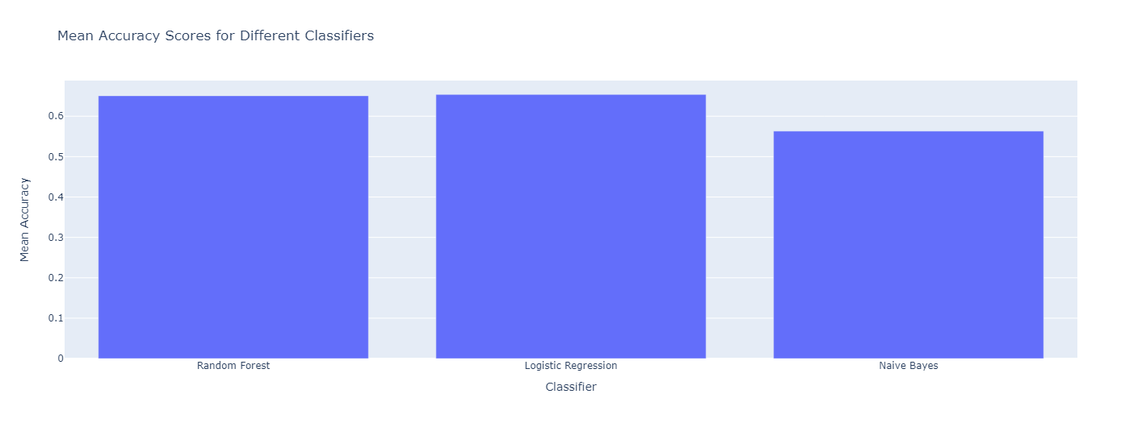

**Fig. 1.** Predictive ML Models Outcome

The results of the experiment indicate that Logistic Regression exhibited somewhat superior performance compared to Random Forest, however, Naive Bayes showed comparatively lower performance. The comparable performance seen between the Random Forest and Logistic Regression models indicates that both models successfully captured the underlying patterns present in the data. In contrast, the Naive Bayes model may have oversimplified the relationships between variables.

# **Conclusion**

The transition from the initial phase of data discovery to the subsequent stage of model development has yielded significant revelations on the sentiments conveyed in user reviews and their potential associations with product problems.

## **What does the analysis/model building tell you?**

The investigation highlights the importance of consumer emotions as indicators of probable product problems. The Random Forest and Logistic Regression models demonstrated their ability to identify significant trends, hence highlighting their potential in utilizing emotional data for predictive analytics.

## **Is this model ready to be deployed?**

Although the accuracy of the models, particularly Logistic Regression and Random Forest, shows promise, it is important to acknowledge that deploying them in a real-world context necessitates more thorough testing. It is imperative to assess the model's resilience by evaluating its performance not only on historical data but also on novel, unseen data. Before installing, it is imperative to take into account variables such as scalability, processing efficiency, and interaction with pre-existing systems.

## **Recommendations**

One of the primary suggestions is to enhance the dataset by incorporating additional features. By incorporating elements such as product categories and exploring the contextual factors around reviews, we may greatly improve the prediction capabilities of our models. The subtle intricacies of machine learning models frequently constitute their fundamental nature. The deliberate optimization of hyperparameters, particularly for models such as Random Forest, has the potential to significantly enhance accuracy rates. Relying exclusively on a single model might occasionally impose limitations. The utilization of an ensemble technique, which involves combining predictions from high-performing models, may offer a viable method for attaining higher outcomes. This approach effectively capitalizes on the advantages of each distinct model while simultaneously mitigating their respective limitations. Consumer sentiment is a significant component of our dataset. The utilization of sophisticated sentiment analysis methods can yield a more detailed and subtle comprehension of the evaluations, facilitating improved anticipation of product flaws and providing more comprehensive insights into consumer behavior.

## **Challenges**

An issue commonly encountered in numerous datasets is the disparity in class distribution. If specific emotions are not adequately represented in our dataset, there is a significant possibility that our algorithms may struggle to reliably detect them in real-world situations. In the rapidly changing landscape of the digital realm, there is a continuous and persistent influx of data. It is crucial to ensure that our models are able to scale effectively in response to the increasing amount of data, while also preserving their efficiency and accuracy. Reviews, inherently, possess a certain degree of personal subjectivity. The expression of emotions might vary significantly amongst various persons, necessitating the need for our models to possess a high level of proficiency in recognizing a diverse range of emotional manifestations.

## **Opportunities**

In addition to the existing obstacles, there exist significant opportunities. When utilized proficiently, our models possess the potential to provide immediate input, enabling organizations to promptly rectify product flaws and improve user contentment. Personalization holds great significance in the expansive domain of marketing. By acquiring a more fundamental comprehension of customer emotions, organizations can customize their marketing methods to establish a stronger resonance with individual consumers. The integration of our models with recommendation systems enables them to fulfill a dual function. The ability to identify potential product flaws and provide a full evaluation of product quality, together with consumer satisfaction measures, allows for the provision of comprehensive insights.